Article

Machine learning based multi-parameter modeling for prediction of post-inflammatory lung changes

1

|  |
| --- |
| **Citation:** To be added by editorial staff during production.  Academic Editor: Firstname Lastname  Received: date  Revised: date  Accepted: date  Published: date    **Copyright:** © 2024 by the authors. Submitted for possible open access publication under the terms and conditions of the Creative Commons Attribution (CC BY) license (https://creativecommons.org/licenses/by/4.0/). |

1 Department of Radiology, Medical University Innsbruck, Anichstrasse 35, 6020 Innsbruck, Austria.

**Abstract:**

Purpose:   
Prediction of lung function deficits following pulmonary infection with computed tomography (CT) findings, demographic, clinical and biochemical explanatory factors and characteristic of acute infection is challenging and suffers accuracy. In recent years, artificial intelligence has transformed medical data analysis and may improve multi-parameter modeling. Purpose was to develop machine learning models for prediction of post-inflammatory lung changes.

Material and Methods:   
From the prospective CovILD study, data from 420 longitudinal observations from 140 COVID-19 survivors with complete lung function testing and chest CT including human CT severity scoring and CT lung density quantification were used to develop an evaluate machine learning multi-parameter models for prediction of lung function test abnormalities and numeric readouts during post-inflammatory convalescence.

Results/Conclusion:   
Multi-parameter machine learning models which include CT lung density quantification outperformed standalone markers in predicting functional lung deficits, which in future may improve outcome prediction and personalized treatment.

**Keywords:** Covid, Artificial Intelligence, Lung CT, Quantification

1. Introduction

Pulmonary computed tomography (CT) has emerged as a cornerstone in the assessment of diverse lung pathologies, ranging from early-stage malignancies to chronic obstructive pulmonary disease (COPD), interstitial lung diseases (ILDs), and infection, such as COVID-19 pneumonia. Traditional approaches to interpreting pulmonary CT scans have predominantly relied on manual assessment by radiologists, a process characterized by subjectivity, time intensity, and inter-observer variability (1). The recent integration of CT quantification techniques has offered a multifaceted arsenal of advantages over conventional scoring techniques, allowing for rapid and consistent analysis of voluminous imaging datasets (2). Recent studies have demonstrated the potential of AI algorithms to accurately detect and quantify COVID-19-related inflammatory lung changes on CT scans (3, 4). As such, CT quantification may not only facilitate risk stratification but may also contribute to our understanding of disease progression and treatment response (5). Furthermore, it may facilitate the identification of novel imaging biomarkers indicative of disease severity, prognosis, and therapeutic efficacy (6).

However, the prediction of lung function deficits following COVID-19 suffers from low accuracy (12). Additionally, relevance of residual structural lung lesions in CT and severity of lung damage in COVD-19 convalescents for pulmonary function is not entirely clear (9,11).

Machine learning based multi-parameter modeling may overcome some limitations of univariate correlations and receiver operating curve (ROC) analysis. The purpose of this paper was to develop and evaluate machine learning multi-parameter models with demographic, clinical, biochemical and CT quantitative data for prediction of post-inflammatory lung changes in patients who had COVID-19.

2. Materials and Methods  
  
Study data  
Available data from the prospective multicenter CovILD study was used for this study (Medical University of Innsbruck, Austria (approval number: 1103/2020); ClinicalTrials.gov (NCT04416100). For detailed information on the study design and the cohort please refer to our recent publications (9–12). In brief, the study aimed at investigation of symptoms, cardiopulmonary and mental health recovery in a cohort of 145 COVID-19 survivors at two, three, six, and twelve months after COVID-19 diagnosis. The participants were recruited between March and June 2020 among patients of three clinical centers in Tyrol, Austria (Medical University of Innsbruck, St. Vinzenz Hospital in Zams, and Karl-Landsteiner Rehabilitation Center in Münster). The study inclusion criteria were age ≥ 18 years, SARS-CoV-2 positivity confirmed by PCR and presence of COVID-19 symptoms. All participants were infected with the wild-type form of SARS-CoV-2. Herein, n = 420 longitudinal observations from 140 participants were analyzed, with complete computed tomography (CT) of the chest and lung function testing (LFT) as analysis inclusion criteria. The severity of lung lesions in CT was scored by thoracic radiologists based on a CT severity score (CTSS). In addition, an AI-based software (Syngo.via CT Pneumonia Analysis Software, Siemens Healthineers, Erlangen, Germany) was used to quantify lung density as the percentages of the lung with opacity including high opacity (consolidation), as described before in detail (9, 10).

Machine learning based multi-parameter modeling - Analysis endpoints  
The primary analysis endpoint was construction and evaluation of multi-parameter models. The most common LFT abnormalities, i.e. DLCO (diffusion capacity for carbon monoxide) < 80%, FVC (forced vital capacity) < 80%, FEV1 (forced expiratory volume in the first one second) < 80% of the patient’s reference, and numeric readouts, i.e DLCO, FVC, FEV1 in the CovILD cohort were modeled with a broad panel of 37 independent variables including baseline demographic and clinical characteristic (e.g. gender, age, smoking history, comorbidity), characteristic of acute COVID-19 (e.g. severity, medication, hospitalization) and convalescence (follow-up time point, persistent symptoms), as well as presence and severity of CT abnormalities (e.g. CTSS (CT severity score), AI-determined opacity and high opacity). To this end, we employed four popular machine learning algorithms, Random Forest (19), gradient boosted machines (GBM) (21,22), neural network with a single hidden layer (23), and support vector machines (SVM) (24). Because the CovILD data set consisted of non-independent, participant-matched observations, blocked cross-validation with participant’s identifier serving as the grouping variable was used for model optimization (tuning, Supplementary Table S6). Predictions of the models were finally evaluated by comparison with the observed outcome in the training data and the blocked cross-validation folds (26) (Supplementary Figure S8, Table 2 and 3, Supplementary Tables S7 and S8). The secondary analysis endpoint was prediction of LFT abnormalities and numeric LFT readouts during recovery by human-determined CTSS and AI-measured CT lung opacity and high opacity. This endpoint was addressed by statistical hypothesis testing, correlation and receiver-operating characteristic (ROC) analysis.

Statistical analysis  
Details of statistical analysis are provided in Supplementary Methods.  
Statistical analysis was performed with R version 4.2.3 (R Foundation for Statistical Computing). Numeric variables were presented as medians with interquartile ranges and ranges. Qualitative variables were presented as percentages and counts of the categories within the complete observations set. Differences in independently distributed numeric variables were analyzed by Mann-Whitney and Kruskal-Wallis test with, respectively, biseral r and η^2 effect size statistic. Statistical significance for differences in distribution of qualitative variables was determined by χ^2 test with Cramer’s V effect size statistic. Co-occurrence of each of LFT findings, CT abnormalities, and symptoms was investigated by two-dimensional correspondence analysis (14).  
Differences in medians of non-independently distributed, participant matched numeric variables between observations with and without LFT abnormalities were assessed by a blocked bootstrap test with blocks defined by the participant’s identifier, and effect size measured by biseral r effect size statistic (15). Correlations of non-independently distributed CT and LFT readouts were assessed by blocked bootstrap Spearman’s rank test. Cutoffs of CTSS, opacity and high opacity for detection of LFT abnormalities were found by maximizing the Youden’s J statistic. ROC analysis statistics (area under the curve [AUC], sensitivity, specificity, Cohen’s κ) for those optimal cutoffs were computed and their 95% confidence intervals were obtained by blocked bootstrap (16,17).  
Presence of reduced DLCO, FVC and FEV1 (each < 80% of reference), as well as values of DLCO, FVC and FEV1 expressed as percentages of the reference value were modeled with 37 explanatory variables. The explanatory variables included demographic features (e.g. age, sex, body mass index, smoking, comorbidity), characteristic of acute COVID-19 (severity, medication) and recovery (e.g. weight loss, symptoms of relevance for lung function, time after diagnosis), and presence of human- and AI-rated structural lung abnormalities in CT scans (e.g. GGO, CTSS, opacity and high opacity). The modeling responses and explanatory variables are listed in Supplementary Table S2. The models were constructed with four common machine learning algorithms: Random Forest (18,19), gradient boosted machines (GBM) (10–22), neural network with a single hidden layer (23), and support vector machines (SVM) with radial kernel (24,25). Selection of the optimal values of parameters controlling model behavior such as number of random trees, neurons in the hidden layer, or cost parameter was motivated by the maximum of Youden’s J statistic (classification models of LFT abnormalities) or minimum mean absolute error (MAE, regression models of LFT readouts) in 10-repeats 10-fold cross-validation (26). Because of the presence of participant-matched observation, blocked cross-validation design was used both in the model selection and model evaluation, with blocks defined by participant’s identifier. Model predictions were evaluated both in the training data and blocked 10-repeats 10-fold cross-validation. Concordance between the model-predicted and observed outcomes for classification models was assessed by Cohen’s κ inter-rater reliability statistic (16,27). Accuracy, AUC, specificity and sensitivity of the classification model were investigated by ROC. Calibration of the classification models was assessed by Brier scores (28). Fraction of explained variance in predictions of the regression models was measured by pseudo-R2, the regression model error was expressed as MAE. Spearman’s ρ coefficients of correlation between the predicted and observed values were used to gauge calibration of the regression models. Importance of explanatory variables was estimated by absolute values of SHAP statistics (Shapley additive explanations) (29–31).

3. Results

Machine learning based multi-modal modeling of lung function impairment   
Among the investigated LFT abnormalities, solely reduced DLCO defined as values < 80% of the patient’s reference could be modeled with satisfactory accuracy in the cross-validation setting independently of the machine learning algorithm (overall accuracy: 0.82 to 0.85, Cohen’s κ: 0.45 to 0.5, AUC: 0.87 to 0.9). Low Brier score values for the models of insufficient DLCO indicated good overall calibration (Brier score: 0.11 to 0.14, Figure 1A). In turn, models of reduced FVC and FEV1 exhibited poor predictive performance in the cross-validation setting (overall accuracy: 0.72 to 0.81, Cohen’s κ: 0.094 to 0.17, AUC: 0.57 to 0.69, Supplementary Figure S9).

As in case of the LFT abnormalities, solely DLCO expressed as percentages of the patient’s reference was modeled with sufficiently low error and substantial explanatory power in cross-validation with the Random Forest, GBM, and SVM algorithms (MAE: 11.6 to 12.5, pseudo-R2: 0.26 to 0.34). Those models were also characterized by good calibration assessed by Spearman’s ρ coefficients of correlation between the predicted and observed DLCO (Spearman’s ρ: 0.55 to 0.59). By contrast, the neural network model of DLCO suffered from large error and low fraction of explained variance in the cross-validation setting (MAE = 13.8, pseudo-R2 = 0.043, Figure 1B). Analogically, no meaningful models of FVC or FEV1 could be developed with any of the machine learning algorithms (cross-validation, R2: -0.086 to -0.03, Supplementary Figure S10).

Explanatory variable importance for models of reduced DLCO measured by Shapley additive explanations are demonstrated in Figure 2.

The cross-validated performance of binary machine learning classifiers and regression machine learning models at predicting lung function testing (LFT) abnormalities are shown in Table 1 and 2.

**Rating of CT structural lung damage by human CTSS or AI-determined density quantification and lung function impairment**

Human-determined CTSS (difference of medians: 9 points, p < 0.001, effect size: r = 0.57), AI-determined opacity (difference of medians: 1.3% of the lung, p < 0.001, effect size: r = 0.63) and high opacity (difference of medians: 0.063, p < 0.001% of the lung, effect size: r = 0.58) were significantly higher in observations with DLCO < 80% of the patient’s reference than in the remaining data points. The effect size of those differences was large (see Figure 3). Table 3 shows the detection of reduced DLCO < 80% reference value by AI-determined opacity and high opacity, and human-determined CT severity score.

3.2. Figures, Tables and Schemes

Figure 1. Evaluation of performance of machine learning models of DLCO during COVID-19 convalescence.

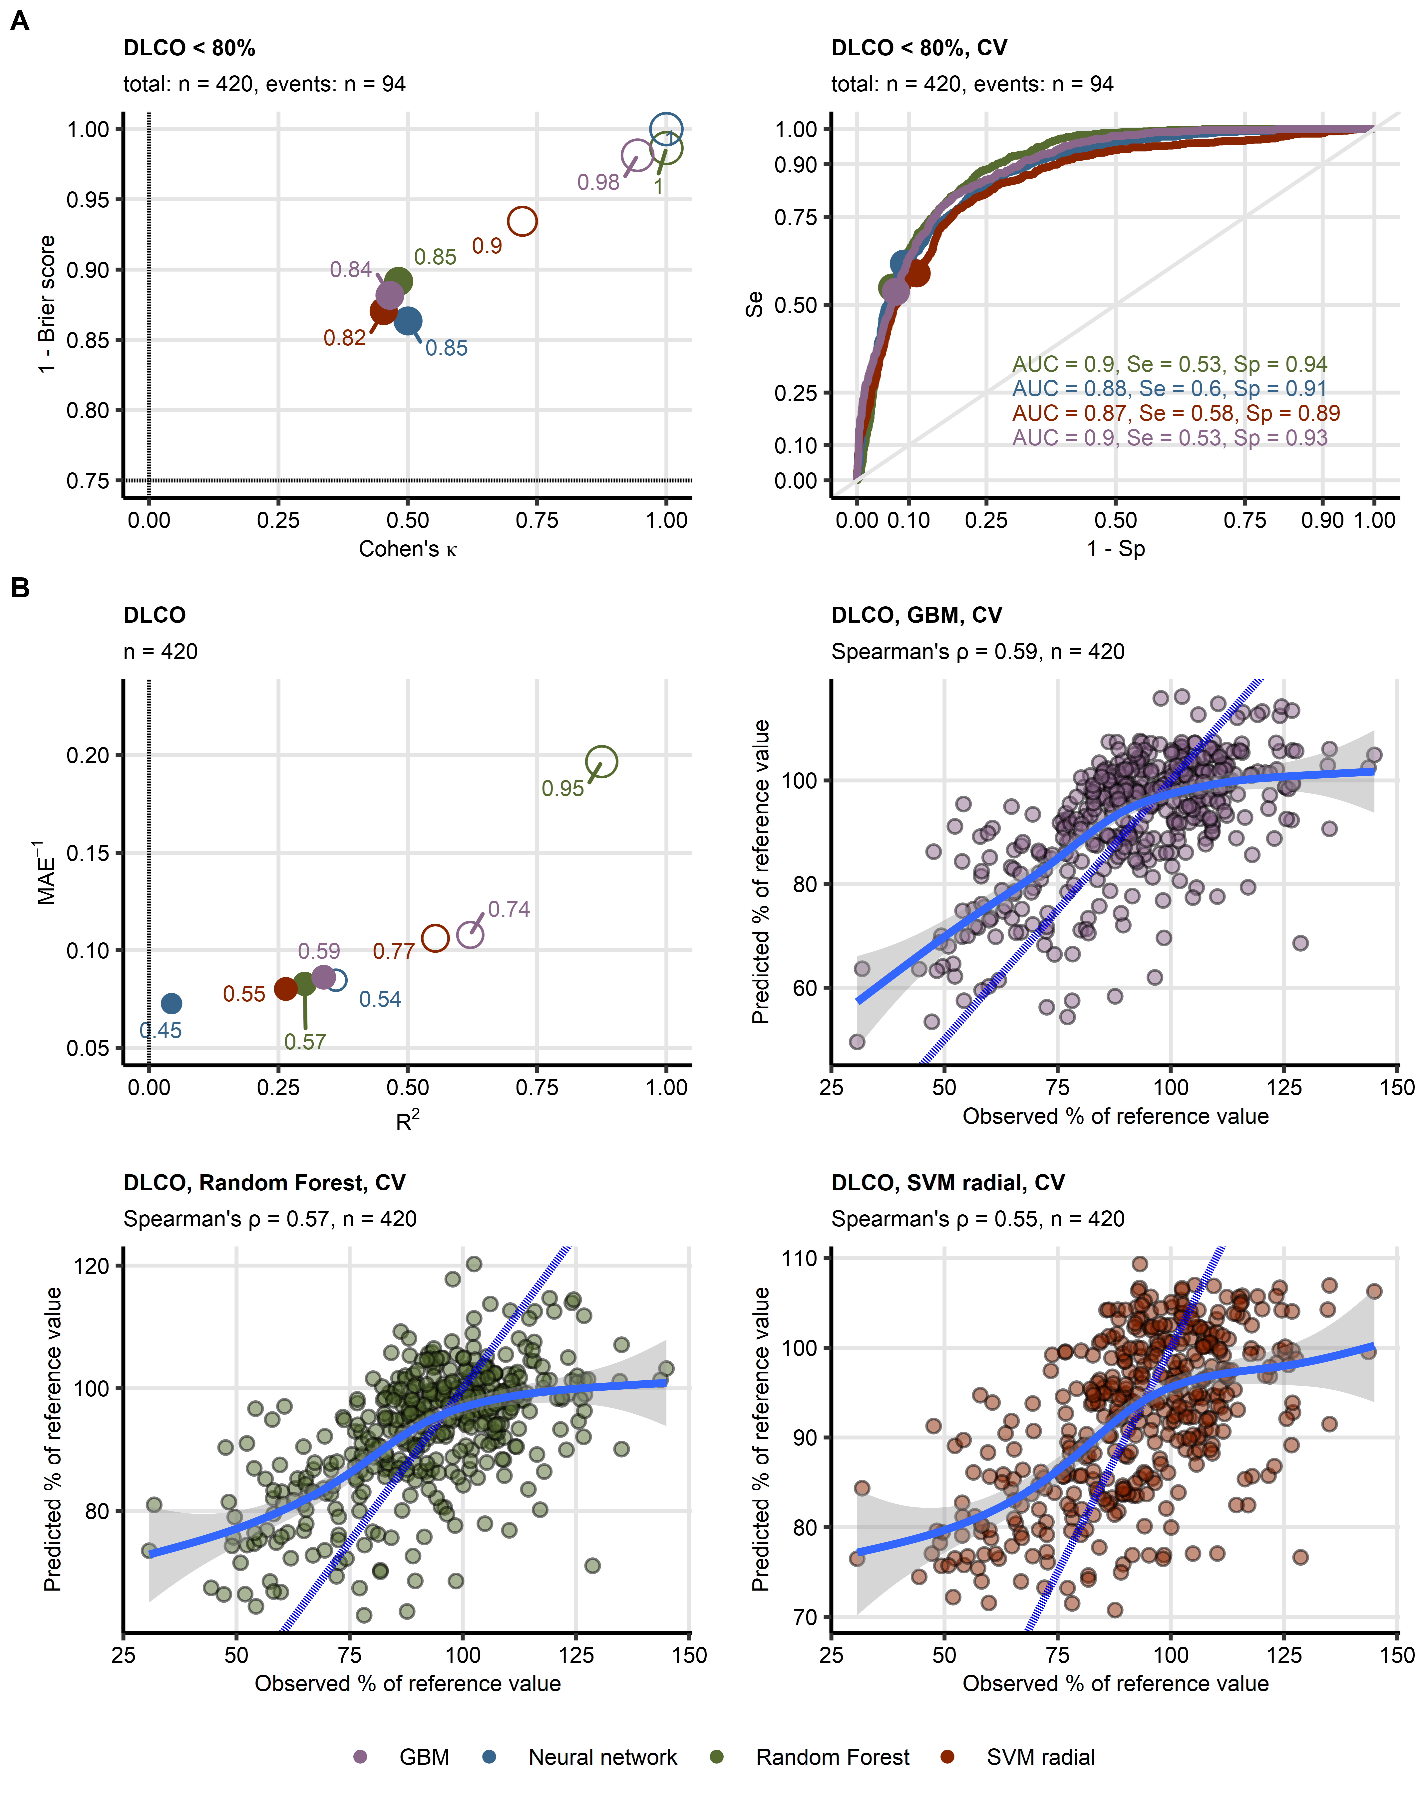

(A) Four machine learning classification models of insufficient diffusion capacity for carbon monoxide (< 80% of reference value: n = 94, total observations: n = 420) employing computed tomography readouts, demographic and clinical explanatory variables were trained. Their performance was evaluated in the entire data set and 10-repeats 10-fold cross-validation with overall accuracy metric, Cohen’s κ as a measure of concordance between predicted and observed outcome, and Brier score as a measure of model’s calibration. Left: numeric performance measures of the models (open circles: the entire data set, filled circles: cross-validation); point sizes and point labels represent overall model accuracy, the dashed lines visualize values of Cohen’s κ and Brier score expected for prediction of insufficient DLCO be chance. Right: receiver-operating characteristic curves for predictions in cross-validation folds, numeric statistics are displayed in the plot. Numbers of complete observations and observations witj DLCO insufficiency (‘events’) are displayed in the plot captions.

(B) Four machine learning regression models of diffusion capacity for carbon monoxide (percentage of reference values, total observations: n = 420) employing computed tomography readouts, demographic and clinical explanatory variables were trained. Their performance was evaluated in the entire data set and 10-repeats 10-fold cross-validation with R^2 as a measure of explained variation, mean absolute error, and ρ Spearman’s coefficient of correlation between the predicted and observed values. Bubble plot: numeric performance measures of the model (open circles: the entire data set, filled circles: cross-validation); point sizes and point labels represent values of ρ correlation coefficient, the dashed line visualizes R^2 value expected for a meaningless model. Scatter plots: observed and predicted values of diffusion capacity for carbon monoxide in cross-validation folds; the blue dashed lines with slope 1 and intercept 0 represent absolutely accurate predictions, general additive model trends with standard errors are visualized as the solid blue lines with gray ribbons. Numbers of complete observations and Spearman’s ρ coeffficients of correlation between the predicted and observed values are displayed in the plot captions.

DLCO: diffusion capacity for carbon monoxide, CV: cross-validation; AUC: are under the receiver-operating characteristic curve; Se: sensitivity; Sp: specificity; MAE: mean absolute error; GBM: gradient boosted machines; SVM radial: support vector machines with radial kernel.

Figure 2. Explanatory variable importance for models of reduced DLCO measured by Shapley additive explanations.

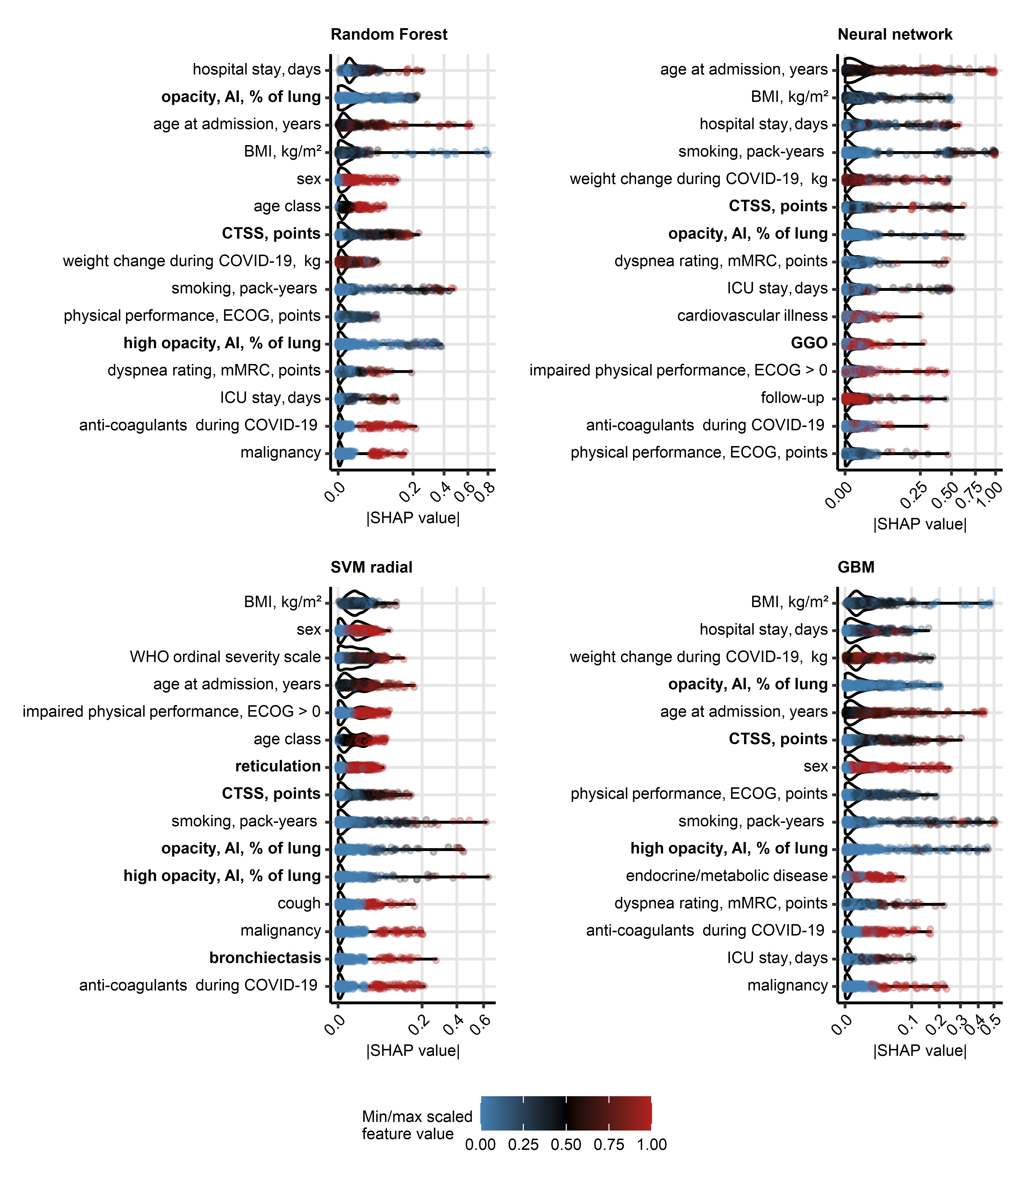

Importance of explanatory variables for the machine learning models of reduced DLCO (< 80% of reference) was investigated by Shapley additive explanations (SHAP). Absolute SHAP values for explanatory variables with the 15 largest mean SHAP values are presented in violin plots. Points represent single observations, point colors code for minimum/maximum scaled value of the explanatory variable. Explanatory variables obtained via computed tomography are highlighted with bold font in the Y axes.  
CT: computed tomography; DLCO: diffusion capacity for carbon monoxide; opacity and high opacity, AI: opacity and high opacity of the lung determined by artificial intelligence; BMI: body mass index; CTSS: human-determined CT severity score, sum for all lobes; ECOG: Eastern Cooperative Oncology Group physical performance score; mMRC: modified Medical Research Council dyspnea scale; ICU: intensive care unit.

Figure 3. Detection of DLCO insufficiency by human- and artificial intelligence-determined CT readouts of severity of structural lung damage.

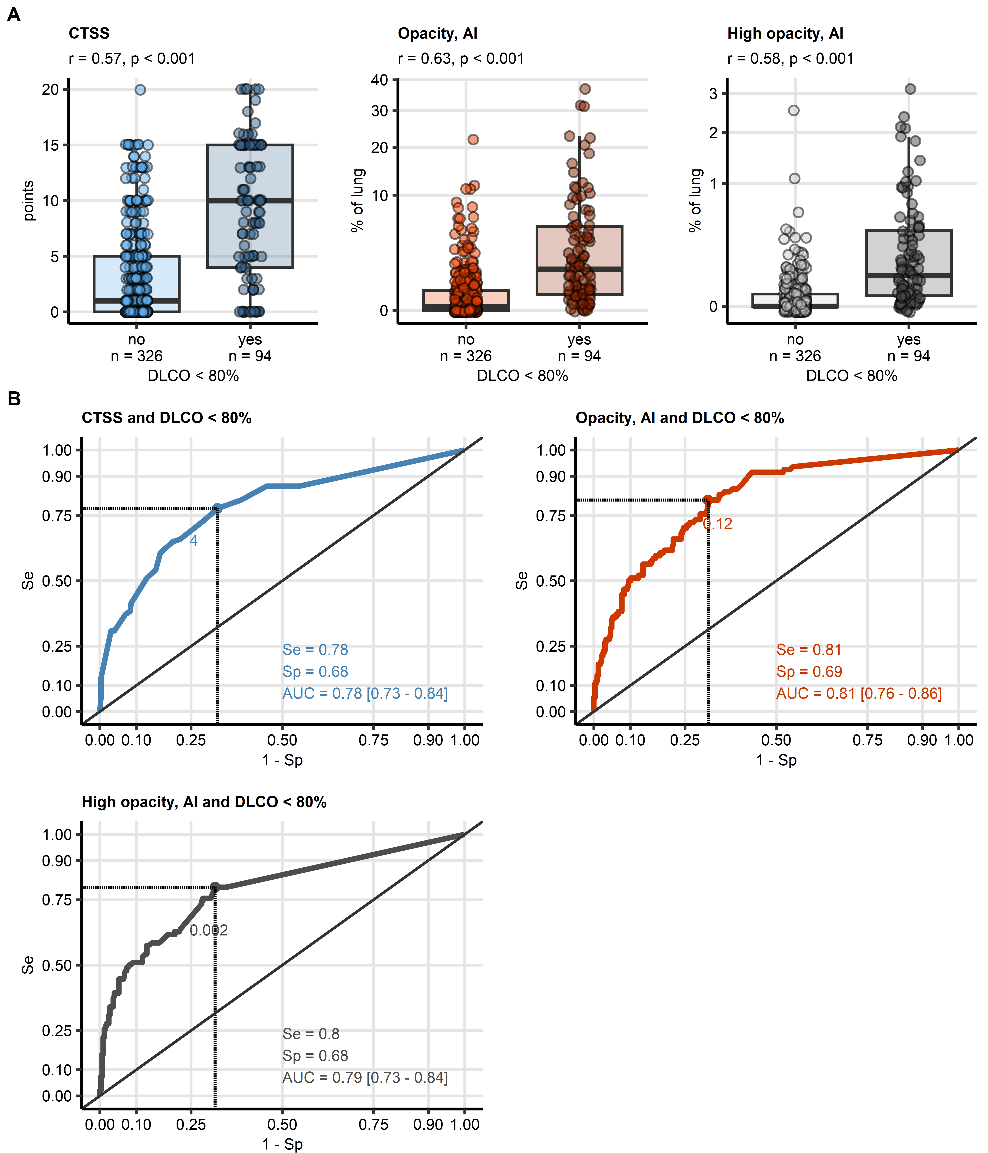

Human- and AI-determined CT readouts of structural lung damage were identified as influential explanatory variables at prediction of insufficiency of DLCO (< 80%) by machine learning.

(A) Values of the radiological readouts of lung damage severity were compared between data points with and without insufficient diffusion capacity for carbon monoxide by Mann-Whitney test with r effect size statistic. Median values with interquartile ranges are depicted as boxes, whiskers span over 150% of the interquartile ranges, single observations are visualized as points. Effect sizes and p values are displayed in the plot captions. Numbers of observations are indicated in the X axis.

(B) Quality of detection of insufficient diffusion capacity for carbon monoxide with the radiological readouts of lung damage severity was assessed by receiver-operating characteristic (ROC) analysis. ROC curves are shown, the optimal cutoffs of the severity readuts determined by Youden’s criterion are represented by points with numbers. Sensitivity, specificity at the optimal cutoff, and area under the curve statistic with 95% confidence interval are displayed in the plots.

CT: computed tomography; DLCO: diffusion capacity for carbon monoxide; CTSS: human-determined CT severity score, sum for all lobes; opacity and high opacity, AI: opacity and high opacity of the lung determined by artificial intelligence; AUC: are under the curve of receiver-operating characteristic; Se: sensitivity; Sp: specificity.

**Tables:**

Table 1: Cross-validated performance of binary machine learning classifiers at predicting lung function testing (LFT) abnormalities.

| **Responsea** | **Algorithmb** | **Overall accuracyc** | **κd** | **Brier score** | **AUCe** | **Sensitivity** | **Specificity** |
| --- | --- | --- | --- | --- | --- | --- | --- |
| DLCO < 80% | Random Forest | 0.85 | 0.480 | 0.11 | 0.90 | 0.53 | 0.94 |
| Neural network | 0.85 | 0.500 | 0.14 | 0.88 | 0.60 | 0.91 |
| SVM radial | 0.82 | 0.450 | 0.13 | 0.87 | 0.58 | 0.89 |
| GBM | 0.84 | 0.470 | 0.12 | 0.90 | 0.53 | 0.93 |
| FVC < 80% | Random Forest | 0.79 | 0.110 | 0.16 | 0.69 | 0.14 | 0.95 |
| Neural network | 0.72 | 0.094 | 0.25 | 0.58 | 0.27 | 0.83 |
| SVM radial | 0.78 | 0.120 | 0.16 | 0.68 | 0.19 | 0.92 |
| GBM | 0.78 | 0.150 | 0.17 | 0.67 | 0.21 | 0.92 |
| FEV1 < 80% | Random Forest | 0.80 | 0.120 | 0.15 | 0.64 | 0.15 | 0.95 |
| Neural network | 0.75 | 0.110 | 0.21 | 0.57 | 0.26 | 0.86 |
| SVM radial | 0.80 | 0.130 | 0.16 | 0.59 | 0.18 | 0.94 |
| GBM | 0.81 | 0.170 | 0.16 | 0.61 | 0.21 | 0.94 |
| aLFT: lung function testing, DLCO: diffusion capacity for CO, FVC: forced vital capacity; FEV1: forced expiratory volume in one second. | | | | | | | |
| bSVM: support vector machines with radial kernel; GBM: gradient boosted machines. | | | | | | | |
| cRatio of correct predictions to the total observation number. | | | | | | | |
| dCohen κ statistic of inter-rater reliability between the predicted and observed outcome. | | | | | | | |
| eAUC: are under the receiver-operating characteristic curve. | | | | | | | |

Table 2: Cross-validated performance of regression machine learning models at predicting values of lung function testing parameters.

| **Responsea** | **Algorithmb** | **pseudo-R²c** | **MAEd** | **ρe** |
| --- | --- | --- | --- | --- |
| DLCO | Random Forest | 0.300 | 12 | 0.570 |
| Neural network | 0.043 | 14 | 0.450 |
| SVM radial | 0.260 | 12 | 0.550 |
| GBM | 0.340 | 12 | 0.590 |
| FVC | Random Forest | -0.030 | 10 | 0.220 |
| Neural network | -0.079 | 11 | 0.074 |
| SVM radial | -0.031 | 10 | 0.210 |
| GBM | -0.040 | 10 | 0.200 |
| FEV1 | Random Forest | -0.045 | 12 | 0.160 |
| Neural network | -0.086 | 12 | 0.210 |
| SVM radial | -0.039 | 11 | 0.190 |
| GBM | -0.047 | 12 | 0.170 |
| aDLCO: diffusion capacity for CO, FVC: forced vital capacity; FEV1: forced expiratory volume in one second. | | | | |
| bSVM: support vector machines with radial kernel; GBM: gradient boosted machines. | | | | |
| cDefined as 1 - ratio of mean squared error and variance. | | | | |
| dMAE: mean absolute error. | | | | |
| eΡ: Spearman coefficient of correlation between the predicted and observed response values. | | | | |

Table 3: Detection of reduced diffusion capacity for CO DLCO < 80% reference value) by single CT-derived parameters: AI-determined opacity and high opacity, and human-determined CT severity score.

| **CT variablea** | **Cutoffb** | **Statisticc** | **Value, 95% CI** |
| --- | --- | --- | --- |
| CTSS |  | AUC | 0.78 [0.727 - 0.84] |
| 4.000 | κ | 0.34 [0.23 - 0.45] |
| 4.000 | Sensitivity | 0.78 [0.64 - 0.89] |
| 4.000 | Specificity | 0.68 [0.6 - 0.75] |
| high opacity, AI |  | AUC | 0.79 [0.734 - 0.84] |
| 0.002 | κ | 0.37 [0.26 - 0.47] |
| 0.002 | Sensitivity | 0.8 [0.7 - 0.89] |
| 0.002 | Specificity | 0.68 [0.62 - 0.75] |
| opacity, AI |  | AUC | 0.81 [0.763 - 0.86] |
| 0.120 | κ | 0.38 [0.27 - 0.48] |
| 0.120 | Sensitivity | 0.81 [0.72 - 0.89] |
| 0.120 | Specificity | 0.69 [0.62 - 0.75] |
| aCTSS: human-determined CT severity score, sum for al lung lobes; high opacity and opacity, AI: percentage of the lungs with high opacity and opacity determined by artificial intelligence. | | | |
| bCutoff of the CT variable corresponding to the maximum of Jouden Y statistic. | | | |
| cAUC: area under the curve of receiver-operating characteristic; κ: Cohen κ statistic of inter-rater reliability between the predicted and observed outcome, computed for the CT variable cutoff; sensitivity and specificity: sensitivity and specificity computed at the CT variable cutoff. | | | |

4. Discussion

Four different machine learning models were developed to predict reduced DLCO < 80% in patients after COVID-19. Concerning the models of reduced DLCO, the highest concordance between the predicted and observed DLCO < 80% was achieved for moderate COVID-19 convalescents at the two- to six-month follow-up examinations (all algorithms, κ: 0.45, 0.69). The accuracy was in turn the poorest for ambulatory patients at the six- and twelve-month follow-up (all algorithms, κ: 0, 0.46, Supplementary Figure S11A). The Random Forest, SVM and GBM models of DLCO expressed as percentage of the patient’s reference exhibited the lowest average errors for moderate COVID-19 survivors (mean error: -2.8 to 2.9). In turn, DLCO values were systematically overestimated for severe COVID-19 patients at the two- to six-month follow-up visits (mean error: 1.2 to 6.5) and underestimated for ambulatory COVID-19 convalescents at the same time points (mean error: -4.2 to 0.12). The best performance in the hospitalized moderate subset is likely attributed to the large number of observations and frequent DLCO deficits in this group of participants available for training of the models (n = 47 observations of DLCO < 80% in 234 observations from moderate COVID-19 patients). Conversely, the numbers of observations from ambulatory COVID-19 patients and numbers of observations DLCO insufficiency in this group was low (10 observations of DLCO < 80% in 85 observations from ambulatory patients) which resulted in relatively poor performance of the machine learning models.

As investigated by absolute values of SHAP variable importance metrics (29,30), human- and AI-derived ratings of structural lung damage belonged to the most influential explanatory variables of the models of DLCO < 80% and the meaningful models of DLCO. Other influential explanatory variables were well characterized risk factors of severe COVID-19 (age, male sex, body mass index, pre-existing malignancy and cardiovascular disease), readouts of acute COVID-19 severity (severity class, WHO ordinal severity scale, hospitalization length, ICU treatment, anti-coagulant treatment, and weight change), smoking intensity (pack-years), as well as rating of physical performance impairment (ECOG) and exertional dyspnea (mMRC).

Because CTSS, lung opacity, and high opacity were identified to be crucial for prediction of reduced DLCO <80% and DLCO by machine learning, we explored the association of the human- and AI-determined readouts of lung damage with DLCO in more detail. AI-measured opacity of the lung, but not CTSS or high opacity, was found to be significantly higher in observations with reduced FVC (difference of medians: 0.4, p = 0.0051, effect size: r = 0.29) and insufficient FEV1 (difference of medians: 0.3, p = 0.009, effect size: r = 0.27); sizes of those effects were, however, small (Supplementary Table S10). Furthermore, CTSS, opacity and high opacity correlated negatively with moderate effect size with DLCO (p < 0.001, Spearman’s ρ: -0.46 to -0.44). Interestingly, the CT readouts of structural lung damage also correlated significantly with FVC (Spearman’s ρ: -0.3 to -0.21) and FEV1 (Spearman’s ρ: -0.27 to -0.14); effect size of those associations was small (Supplementary Table S11).

Finally, in an univariable ROC analysis, human-determined CTSS (AUC = 0.78, 95% CI: 0.73 to 0.84), and AI-determined lung opacity (AUC = 0.81, 95% CI: 0.76 to 0.86) and high opacity (AUC = 0.79, 95% CI: 0.73 to 0.84) were identified as standalone markers of insufficient DLCO in COVID-19 patients. The optimal cutoffs of CTSS, opacity, and high opacity for detection of DLCO < 80% were, respectively, 4 points, 0.12% of the lung, and 0.002% of the lung, and allowed for identification of insufficient DLCO with moderate sensitivity and specificity (sensitivity: 0.78 to 0.81, specificity: 0.68 to 0.69, Figure 4B). In case of the AI measures of lung opacity and high opacity, the extremely low values of the optimal cutoffs let us infer that event low-grade radiological abnormalities can be associated with clinically relevant functional lung impairment. Yet, concordance between the predicted observed DLCO insufficiency assessed by Cohen’s κ for CTSS, opacity, and high opacity as standalone markers (blocked bootstrap κ: 0.34 to 0.38, Table 4) was substantially lower that in the multi-parameter machine learning models (cross-validated κ: 0.45 to 0.5). This underlines the importance of other CT-unrelated explanatory factors such acute disease course for reliable prediction of functional lung deficits in COVID-19 convalescents.

Limitations

Our study has several limitations. First, the overall patient and observation number was low, in particular for ambulatory COVID-19 convalescents. Analogically, the study cohort was enriched in hospitalized individuals with in constitute a minute fraction of COVID-19 patients in the real world setting. Second, complete sets of longitudinal CT and LFT measurements at the two-, three-, six- and twelve-month follow-up examinations were available solely for 55 patients. Especially the number of observations obtained with ambulatory and moderate COVID-19 convalescents at the six- and twelve-month follow-up were substantially lower as compared with earlier time points. The incompleteness of the longitudinal data may have hence compromised performance of the machine learning models in particular for ambulatory COVID-19 cases and at the later time points. Third, because of the limited number of participants and observations, we abstained from definition of a test subset of the data used solely for bias-free model evaluation (hold-out strategy). Instead, both model selection and evaluation was done with blocked repeated cross-validation, which may have overestimated performance of the models. Hence, external validation of our findings in an independent cohort is recommended. Finally, the analyzed cohort was recruited in the initial phase of the pandemic and consisted of individuals infected with the wild-type variant of the SARS-CoV-2 virus. For this reason, it is not completely clear, how our findings translate to the recent variants of the pathogen and how the pulmonary recovery is affected by anti-SARS-CoV-2 immunity, improved treatment and care. However, it is feasible, that the CT severity readouts, human-determined CTSS as well as AI-determined opacity and high opacity, are equally applicable in the post-pandemic setting as standalone markers of functional lung impairment during recovery from COVID-19 and other respiratory infections.

5. Conclusions

AI-based multi-parameter models outperformed univariable correlations and ROC analyses for prediction in predicting functional lung deficits. CT imaging data including CTSS, lung opacity, and high opacity were identified to be crucial for prediction of reduced DLCO <80%. AI-based multi-parameter modeling has the potential to improve outcome prediction and guide personalized treatment.

**Author Contributions:** For research articles with several authors, a short paragraph specifying their individual contributions must be provided. The following statements should be used “Conceptualization, X.X. and Y.Y.; methodology, X.X.; software, X.X.; validation, X.X., Y.Y. and Z.Z.; formal analysis, X.X.; investigation, X.X.; resources, X.X.; data curation, X.X.; writing—original draft preparation, X.X.; writing—review and editing, X.X.; visualization, X.X.; supervision, X.X.; project administration, X.X.; funding acquisition, Y.Y. All authors have read and agreed to the published version of the manuscript.” Please turn to the [CRediT taxonomy](https://img.mdpi.org/data/contributor-role-instruction.pdf) for the term explanation. Authorship must be limited to those who have contributed substantially to the work reported.

**Funding:** This research received no external funding

**Institutional Review Board Statement:** Not applicable

**Informed Consent Statement:** Informed consent was obtained from all subjects involved in the study.

**Data Availability Statement:** We encourage all authors of articles published in MDPI journals to share their research data. In this section, please provide details regarding where data supporting reported results can be found, including links to publicly archived datasets analyzed or generated during the study. Where no new data were created, or where data is unavailable due to privacy or ethical restrictions, a statement is still required. Suggested Data Availability Statements are available in section “MDPI Research Data Policies” at https://www.mdpi.com/ethics.

**Conflicts of Interest:** The authors declare no conflicts of interest.

References

1. Huang L, Han R, Ai T, Yu P, Kang H, Tao Q, Xia L. Serial Quantitative Chest CT Assessment of COVID-19: A Deep Learning Approach. Radiol Cardiothorac Imaging. 2020 Mar 30;2(2):e200075. doi: 10.1148/ryct.2020200075. PMID: 33778562; PMCID: PMC7233442.

2. Mei X, Lee HC, Diao KY, Huang M, Lin B, Liu C, Xie Z, Ma Y, Robson PM, Chung M, Bernheim A, Mani V, Calcagno C, Li K, Li S, Shan H, Lv J, Zhao T, Xia J, Long Q, Steinberger S, Jacobi A, Deyer T, Luksza M, Liu F, Little BP, Fayad ZA, Yang Y. Artificial intelligence-enabled rapid diagnosis of patients with COVID-19. Nat Med. 2020 Aug;26(8):1224-1228. doi: 10.1038/s41591-020-0931-3. Epub 2020 May 19. PMID: 32427924; PMCID: PMC7446729.

3. Ozturk T, Talo M, Yildirim EA, Baloglu UB, Yildirim O, Rajendra Acharya U. Automated detection of COVID-19 cases using deep neural networks with X-ray images. Comput Biol Med. 2020 Jun;121:103792. doi: 10.1016/j.compbiomed.2020.103792. Epub 2020 Apr 28. PMID: 32568675; PMCID: PMC7187882.

4. Shan F, Gao Y, Wang J, Shi W, Shi N, Han M, Xue Z, Shen D, Shi Y. Abnormal lung quantification in chest CT images of COVID-19 patients with deep learning and its application to severity prediction. Med Phys. 2021 Apr;48(4):1633-1645. doi: 10.1002/mp.14609. Epub 2021 Mar 9. PMID: 33225476; PMCID: PMC7753662.

5. Wynants L, Van Calster B, Collins GS, Riley RD, Heinze G, Schuit E, Bonten MMJ, Dahly DL, Damen JAA, Debray TPA, de Jong VMT, De Vos M, Dhiman P, Haller MC, Harhay MO, Henckaerts L, Heus P, Kammer M, Kreuzberger N, Lohmann A, Luijken K, Ma J, Martin GP, McLernon DJ, Andaur Navarro CL, Reitsma JB, Sergeant JC, Shi C, Skoetz N, Smits LJM, Snell KIE, Sperrin M, Spijker R, Steyerberg EW, Takada T, Tzoulaki I, van Kuijk SMJ, van Bussel B, van der Horst ICC, van Royen FS, Verbakel JY, Wallisch C, Wilkinson J, Wolff R, Hooft L, Moons KGM, van Smeden M. Prediction models for diagnosis and prognosis of covid-19: systematic review and critical appraisal. BMJ. 2020 Apr 7;369:m1328. doi: 10.1136/bmj.m1328. Update in: BMJ. 2021 Feb 3;372:n236. Erratum in: BMJ. 2020 Jun 3;369:m2204. PMID: 32265220; PMCID: PMC7222643.

6. Jacobs C, van Rikxoort EM, Twellmann T, Scholten ET, de Jong PA, Kuhnigk JM, Oudkerk M, de Koning HJ, Prokop M, Schaefer-Prokop C, van Ginneken B. Automatic detection of subsolid pulmonary nodules in thoracic computed tomography images. Med Image Anal. 2014 Feb;18(2):374-84. doi: 10.1016/j.media.2013.12.001. Epub 2013 Dec 17. PMID: 24434166.

7. Topol EJ. High-performance medicine: the convergence of human and artificial intelligence. Nat Med. 2019 Jan;25(1):44-56. doi: 10.1038/s41591-018-0300-7. Epub 2019 Jan 7. PMID: 30617339.

8. Chartrand G, Cheng PM, Vorontsov E, Drozdzal M, Turcotte S, Pal CJ, Kadoury S, Tang A. Deep Learning: A Primer for Radiologists. Radiographics. 2017 Nov-Dec;37(7):2113-2131. doi: 10.1148/rg.2017170077. PMID: 29131760.

9. Sahanic S, Tymoszuk P, Luger AK, Hüfner K, Boehm A, Pizzini A, Schwabl C, Koppelstätter S, Kurz K, Asshoff M, et al. COVID-19 and its continuing burden after 12 months: a longitudinal observational prospective multicentre trial. ERJ open research (2023) 9:00317–2022. doi: 10.1183/23120541.00317-2022

10. Sonnweber T, Sahanic S, Pizzini A, Luger A, Schwabl C, Sonnweber B, Kurz K, Koppelstätter S, Haschka D, Petzer V, et al. Cardiopulmonary recovery after COVID-19: An observational prospective multicentre trial. European Respiratory Journal (2021) 57: doi: 10.1183/13993003.03481-2020

11. Luger AK, Sonnweber T, Gruber L, Schwabl C, Cima K, Tymoszuk P, Gerstner AK, Pizzini A, Sahanic S, Boehm A, et al. Chest CT of Lung Injury 1 Year after COVID-19 Pneumonia: The CovILD Study. Radiology (2022) 304:462–470. doi: 10.1148/radiol.211670

12. Sonnweber T, Tymoszuk P, Sahanic S, Boehm A, Pizzini A, Luger A, Schwabl C, Nairz M, Grubwieser P, Kurz K, et al. Investigating phenotypes of pulmonary COVID-19 recovery: A longitudinal observational prospective multicenter trial. eLife (2022) 11: doi: 10.7554/ELIFE.72500

13. Hansell DM, Bankier AA, MacMahon H, McLoud TC, Müller NL, Remy J. Fleischner Society: Glossary of terms for thoracic imaging. (2008) 246:697–722. doi: 10.1148/radiol.2462070712

14. Ripley B. MASS: Support Functions and Datasets for Venables and Ripley’s MASS. (2022) https://cran.r-project.org/package=MASS

15. Mangiafico S. rcompanion: Functions to Support Extension Education Program Evaluation. (2022) https://cran.r-project.org/package=rcompanion

16. McHugh ML. Interrater reliability: the kappa statistic. Biochemia Medica (2012) 22:276. doi: 10.11613/bm.2012.031

17. López-Ratón M, Rodríguez-Álvarez MX, Cadarso-Suárez C, Gude-Sampedro F. Optimalcutpoints: An R package for selecting optimal cutpoints in diagnostic tests. Journal of Statistical Software (2014) 61:1–36. doi: 10.18637/jss.v061.i08

18. Wright MN, Ziegler A. ranger: A Fast Implementation of Random Forests for High Dimensional Data in C++ and R. Journal of Statistical Software (2017) 77:1–17. doi: 10.18637/JSS.V077.I01

19. Breiman L. Random forests. Machine Learning (2001) 45:5–32. doi: 10.1023/A:1010933404324

20. Greenwell B, Boehmke B, Cunningham J, Developers G. gbm: Generalized Boosted Regression Models. (2022) https://cran.r-project.org/package=gbm

21. Friedman JH. Stochastic gradient boosting. Computational Statistics & Data Analysis (2002) 38:367–378. doi: 10.1016/S0167-9473(01)00065-2

22. Friedman JH. Greedy function approximation: A gradient boosting machine. https://doiorg/101214/aos/1013203451 (2001) 29:1189–1232. doi: 10.1214/AOS/1013203451

23. Ripley BD. Pattern recognition and neural networks. Cambridge University Press (2014). doi: 10.1017/CBO9780511812651

24. Weston J, Watkins C. Multi-Class Support Vector Machines. (1998)

25. Karatzoglou A, Hornik K, Smola A, Zeileis A. kernlab - An S4 Package for Kernel Methods in R. Journal of Statistical Software (2004) 11:1–20. doi: 10.18637/JSS.V011.I09

26. Kuhn M. Building predictive models in R using the caret package. Journal of Statistical Software (2008) 28:1–26. doi: 10.18637/jss.v028.i05

27. Cohen J. A Coefficient of Agreement for Nominal Scales. Educational and Psychological Measurement (1960) 20:37–46. doi: 10.1177/001316446002000104

28. Brier GW. VERIFICATION OF FORECASTS EXPRESSED IN TERMS OF PROBABILITY. Monthly Weather Review (1950) 78:1–3. doi: 10.1175/1520-0493(1950)078<0001:vofeit>2.0.co;2

29. Covert I, Lee SI. Improving KernelSHAP: Practical Shapley Value Estimation via Linear Regression. Proceedings of Machine Learning Research (2020) 130:3457–3465. https://arxiv.org/abs/2012.01536v3

30. Lundberg SM, Lee SI. A Unified Approach to Interpreting Model Predictions. Advances in Neural Information Processing Systems (2017) 2017-Decem:4766–4775. https://arxiv.org/abs/1705.07874v2

31. Mayer M, Watson D, Biecek P. kernelshap: Kernel SHAP. (2023) <https://cran.r-project.org/web/packages/kernelshap/index.html>

32. Gao M, Bagci U, Lu L, Wu A, Buty M, Shin HC, Roth H, Papadakis GZ, Depeursinge A, Summers RM, Xu Z, Mollura DJ. Holistic classification of CT attenuation patterns for interstitial lung diseases via deep convolutional neural networks. Comput Methods Biomech Biomed Eng Imaging Vis. 2018;6(1):1-6. doi: 10.1080/21681163.2015.1124249. Epub 2016 Jun 6. PMID: 29623248; PMCID: PMC5881940.

33. Hosny A, Parmar C, Coroller TP, Grossmann P, Zeleznik R, Kumar A, Bussink J, Gillies RJ, Mak RH, Aerts HJWL. Deep learning for lung cancer prognostication: A retrospective multi-cohort radiomics study. PLoS Med. 2018 Nov 30;15(11):e1002711. doi: 10.1371/journal.pmed.1002711. PMID: 30500819; PMCID: PMC6269088.

34. Jacobs C, van Rikxoort EM, Twellmann T, Scholten ET, de Jong PA, Kuhnigk JM, Oudkerk M, de Koning HJ, Prokop M, Schaefer-Prokop C, van Ginneken B. Automatic detection of subsolid pulmonary nodules in thoracic computed tomography images. Med Image Anal. 2014 Feb;18(2):374-84. doi: 10.1016/j.media.2013.12.001. Epub 2013 Dec 17. PMID: 24434166.

35. Soussan M, Chouahnia K, Maisonobe JA, Boubaya M, Eder V, Morère JF, Buvat I. Prognostic implications of volume-based measurements on FDG PET/CT in stage III non-small-cell lung cancer after induction chemotherapy. Eur J Nucl Med Mol Imaging. 2013 May;40(5):668-76. doi: 10.1007/s00259-012-2321-7. Epub 2013 Jan 11. PMID: 23306807.

36. Xu, M., Qi, S., Yue, Y. et al. Segmentation of lung parenchyma in CT images using CNN trained with the clustering algorithm generated dataset. BioMed Eng OnLine 18, 2 (2019). https://doi.org/10.1186/s12938-018-0619-9